Shell

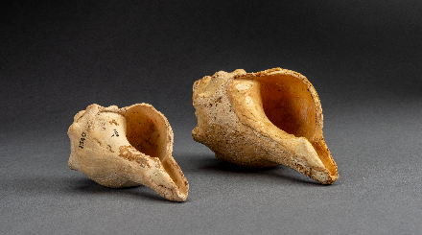
Ancient shells; Turbinella Pyrum; Findspot: Mohenjo-daro, Pakistan; CSMVS (1540, 348)

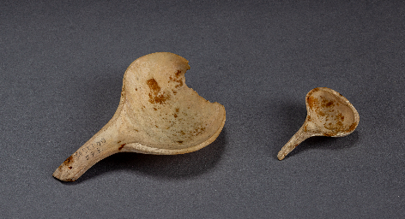
Ladles; Shell; Findspot: Mohenjo-daro, Pakistan; 2600¬1900 BCE; CSMVS (IV 336 339)

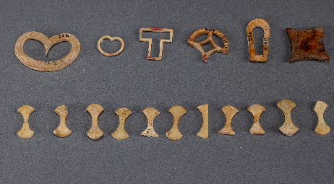

Inlay pieces in different shapes; Shell; Mohenjo-daro, Pakistan; 2600–1900 BCE; CSMVS (IV 321-334, IV 350-352, IV 379)

